For this program to work correctly, the lib (containing the mysql-connector-java-5.1.23-bin), images and config folders must be in the same directory as the HNC_Database.jar file.

The config/properties.txt must be edited to match your database name and password.

Import the HNC_Starter_Tables into your MySQL database

GUI preview:

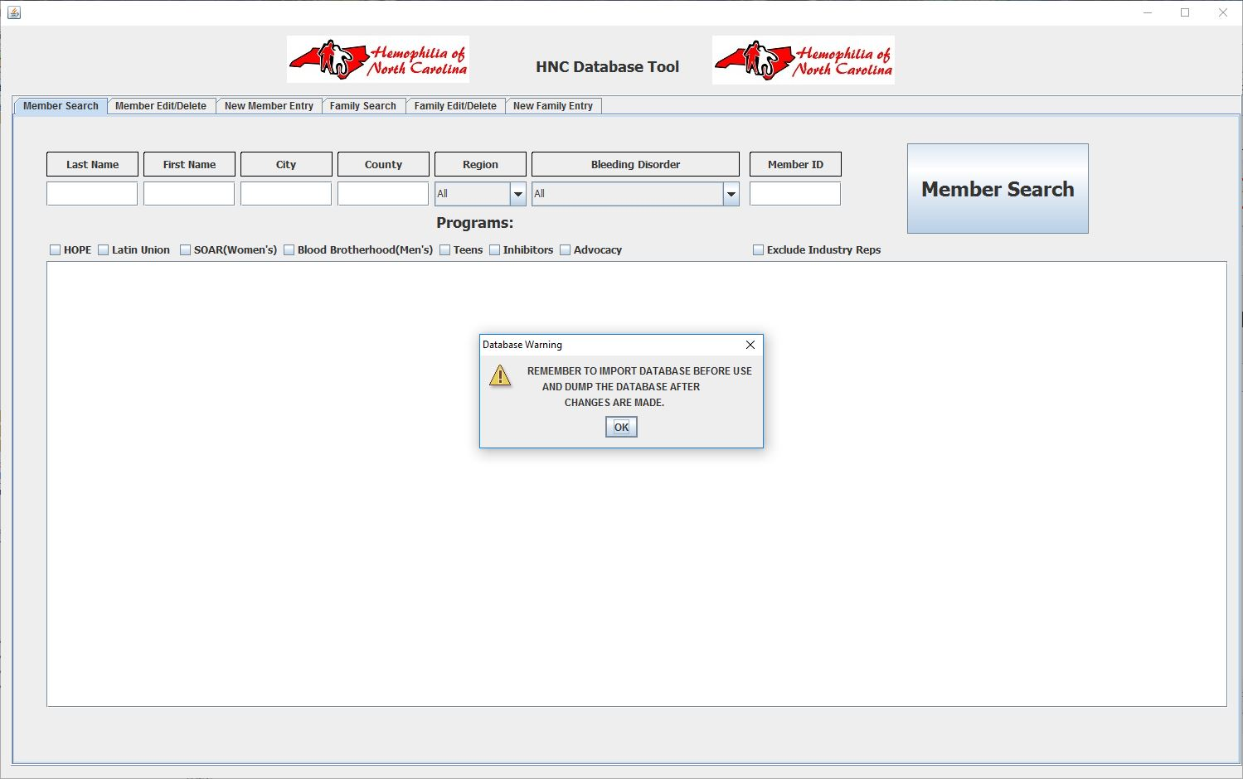

Questions? Contact me at

karlschultz311@gmail.com